CO1 – Assessment 03 15 – 10 – 2026
CODING CHALLENGE
Course code: DSA0308
Course Name: Natural Language Processing
Reg No: 192324300 Harisha S

Question 1
Code:
import re
email = input("Enter Email Address: ")
password = input("Enter Password: ")
mobile = input("Enter Mobile Number: ")
# Email validation
if re.match(r"^[A-Za-z][A-Za-z0-9._]*@[A-Za-z]+\.(com|org|edu|net|in)$", email):
print("Valid Email")
else:
print("Invalid Email")
# Password validation
if re.match(r"^(?=.*[A-Z])(?=.*[a-z])(?=.*\d)(?=.*[@#$%,&.!]).{8,}$", password):
print("Strong Password")
else:
print("Weak Password")
# Mobile number validation
if re.match(r"^[6-9]\d{9}$", mobile):
print("Valid Mobile Number")
else:
print("Invalid Mobile Number")

Output:
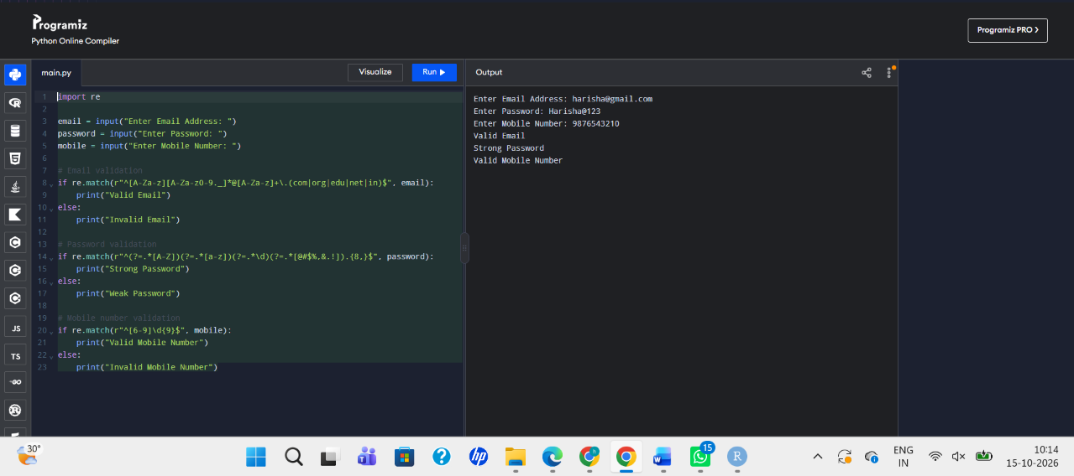
Question 2
Code:
# DFA Simulator for strings ending with "ab"
states = ['q0', 'q1', 'q2']
alphabet = ['a', 'b']
transitions = {
'q0': {'a': 'q1', 'b': 'q0'},
'q1': {'a': 'q1', 'b': 'q2'},
'q2': {'a': 'q1', 'b': 'q0'}
}
initial_state = 'q0'
final_state = 'q2'
n = int(input("Enter number of strings: "))
for i in range(n):
string = input("Enter string: ")
current_state = initial_state
path = [current_state]
valid = True
for ch in string:
if ch not in alphabet:
valid = False
break
current_state = transitions[current_state][ch]
path.append(current_state)
if not valid:
print("Invalid input")
else:
print("Transition Path:")
print(" -> ".join(path))
if current_state == final_state:
print("Accepted")
else:
print("Rejected")
Output:
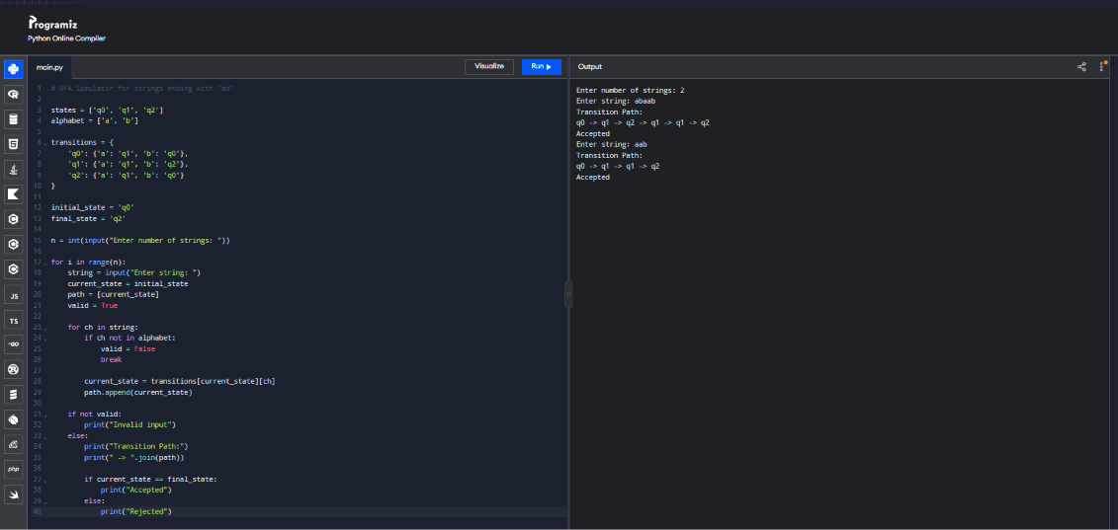

Question 3
Code:
import re
text = input("Enter text: ")
print("1. Search Date")
print("2. Search Phone Number")
print("3. Search Hashtag")
print("4. Search Mention")
print("5. Search Prefix")
print("6. Search Suffix")
print("7. Search Word")
choice = int(input("Enter your choice: "))
if choice == 1:
pattern = r'\b\d{2}/\d{2}/\d{4}\b'
elif choice == 2:
pattern = r'\b[6-9]\d{9}\b'
elif choice == 3:
pattern = r'#\w+'
elif choice == 4:
pattern = r'@\w+'
elif choice == 5:
prefix = input("Enter prefix: ")
pattern = r'\b' + re.escape(prefix) + r'\w*'
elif choice == 6:
suffix = input("Enter suffix: ")
pattern = r'\w*' + re.escape(suffix) + r'\b'
elif choice == 7:
word = input("Enter word: ")
pattern = r'\b' + re.escape(word) + r'\b'
else:
print("Invalid choice")
exit()
matches = re.findall(pattern, text, re.IGNORECASE)
if matches:
print("Matching patterns:", matches)
else:
print("No matching patterns found")
Output:
